**Jack N Jill, Sanatnagar**

**WINTER ASSIGNMENT**

**“INSTRUCTIONS”**

1. **Kindly make your ward practice the winter work on separate notebooks.**
2. **Your are requested to send the winter work notebooks with your wards when the school reopens.**
3. **Don’t forget to send the pictures of your ward during activities.**
4. **Help your wards to do reading of the words that are attached in the english section of the assignment.**

**Class:LKG**

**Subject: English**

**Q1: Converse in English-**

**To develop the communication skills of your children in English ensure to converse small sentences in English only.**

**Teachers are trying to encourage the children to use simple sentences, words and phrases like:**

1. **May I come in Ma’am?**
2. **May I drink water?**
3. **May I go to the toilet?**
4. **I am feeling thirsty.**
5. **I am feeling hungry.**
6. **Please give me a pen.**
7. **Please give me an eraser, etc.**

**Revise the above sentences during this winter break.**

**Children can also be encouraged to use simple words and sentences at home like-**

1. **Mom, I am hungry please give me something to eat.**
2. **Please give me a glass of water.**
3. **Please open/shut the door.**
4. **Please trim my nails.**
5. **Can I watch TV?**
6. **I am feeling sleepy.**

**Q2: Use Magical words.**

**Excuse me, Sorry, Thank you, Please.**

**Q3: Learn to wish “Good Morning”, “Good Afternoon” and “Good evening”.**

**Q4: Reading of the following sight words:**

1. **Is**
2. **The**
3. **I**
4. **Me**
5. **My**
6. **To**
7. **Go**
8. **Of**
9. **At**
10. **He**
11. **She**
12. **In**
13. **It**
14. **A**
15. **And**

**Q5: Reading of vowels and consonants with their phonic sounds.**

**Vowels: a, e, I, o, u**

**Consonants: b, c, d, f, g, h, j, k, l, m, n, p, q, r, s, t, v, w, x, y, z**

**Note: You can also refer to youtube video for the better understanding of your child.**

**Q6: Reading of the following three letter words:**

1. **Bat**
2. **Cat**
3. **Can**
4. **Bed**
5. **Bot**
6. **Cot**
7. **Cup**
8. **But**
9. **Hen**
10. **Hat**
11. **Hut**
12. **Hop**
13. **Jug**
14. **Jet**
15. **Ket**
16. **Mat**
17. **Man**
18. **Mop**
19. **Mug**
20. **Pup**
21. **Pat**
22. **Pin**
23. **Pop**
24. **Rat**
25. **Run**
26. **Sip**
27. **Sat**
28. **Sun**
29. **Wet**
30. **Zip**

**Q6: Buy any Moral story-books for children and ensure to narrate one story daily to your child.**

**“Written Work”**

**Revise capital letters (A-Z).**

**Revise phonics (orally).**

**Subject: Mathematics**

**Learning time-**

**Memorize your Mother’s and Father’s mobile numbers.**

**Craft time:**

**Cut out the basic shapes like Circle, Rectangle, Square and Triangle from the glazed/craft papers and paste it on a chart. You can also decorate them using googly eyes.**

**“Written Work”**

**Revise counting 1-20.**

**Revise backward counting 5-1**

**Subject: EVS**

**Healthy living:**

**Good health may seem the natural at a young age, but maintaining physical and emotional well-being often requires us to develop healthy lifestyle. Having a healthy lifestyle, eating well and physically active helps children to develop strong bones, grow and develop healthily, improves their concentration and make them active and alert.**

**Emphasize your child to spend atleast half-an-hour (30 mins) every morning before breakfast doing these exercises-**

**Jumping, Running, Hop, Practice Aerobics, Simple yoga, Exercises, Bending and then touching feet, Swimming exercise, tapping knees with hands etc.**

**Q1: Make a texture chart and paste different strips of different clothes like cotton, silk, wool, satin etc on it and also paste a strip of sand paper on it.**

**Q2: Paste pictures of fruits, vegetables, pet animals, wild animals, water animals, insects on separate charts.**

**Q3: Partition the chart in two halves and paste pictures of junk food and healthy food on it.**

**Subject: Urdu**

**Q1: Make flash cards of haroof-e-tahaji.**

**Q2: On a chart, make a nest and paste dried grass, twigs and crumbled egg shells on it. Also make a sparrow on it and make your child understand about the importance of nests for birds.**

**“Written work”**

**Q1: Revision of Haroof-e-tahaji.**

**Q2: Say aloud haroofs in between and make your child to write them.**

**Subject: Art**

**Q1: Draw a snowman, cap and socks on a craft paper then cut these thing out and decorate them using cotton, google eyes and sticker stones.**

**Q2: Make a house using matchsticks on a drawing book.**

**Q3: On a drawing book, give thumb impressions of your family. Then name as Mummy, Daddy, Me etc.**

**Q4: Make a DIY Pencil topper.**

**It’s time to be creative and show your art and craft skills, by making a cute pencil topper for your pencil-**

1. **Choose the pencil topper shape. Think about what kind of pencil topper you want to make- a flower, a star, an animal, or even a boy or girl’s face.**
2. **Cut out the shapes drawn on craft foam (2 in number).**
3. **Glue them together.**
4. **Mark the center and punch a hole.**
5. **Slide the topper to the top of a pencil and decorate.**

**“WORKSHEETS”**

**Subject: English**

**Q1: Match the pictures with letters.**

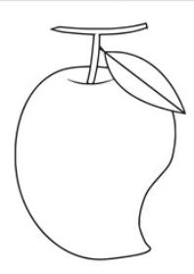 **D**

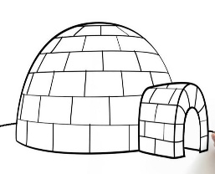 **M**

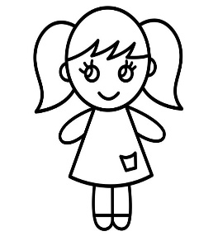 **I**

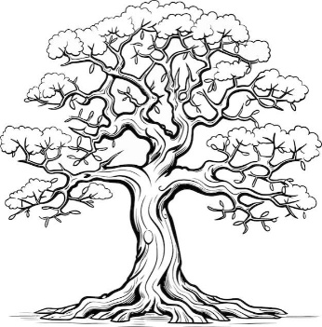**Q2: Circle the first letter for the given pictures.**

**C T M L**

**H V F O**

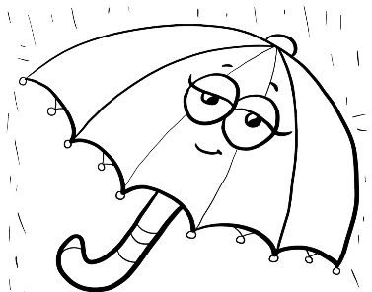

**R S Z U**

**Subject: Mathematics**

**I can count and match.**

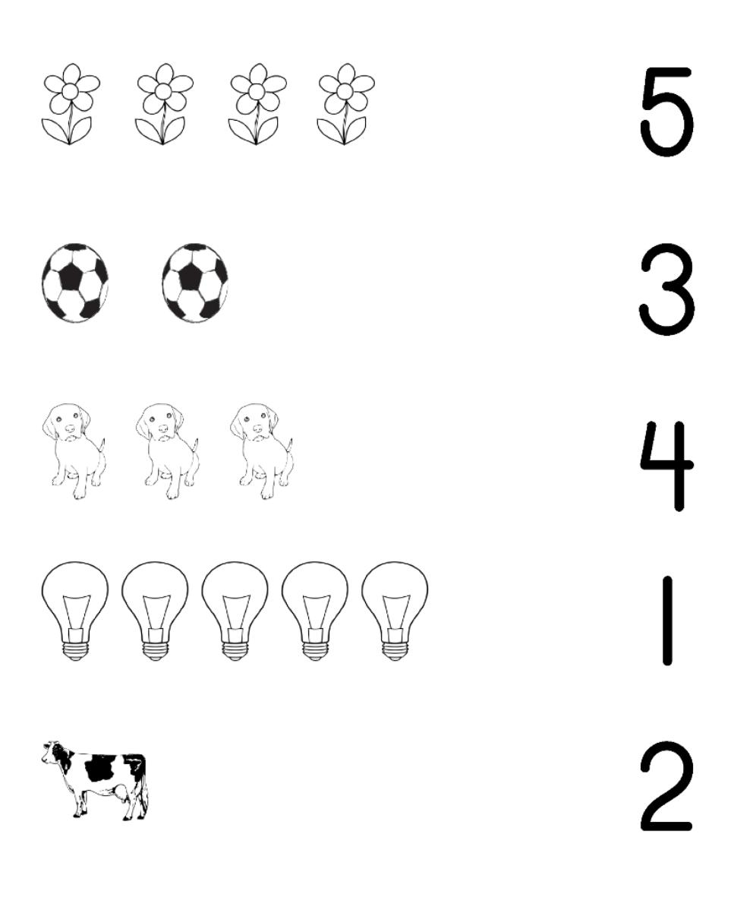

**See the numbers and paste small colourful bindis accordingly in the tortoise shells.**

1. **6**

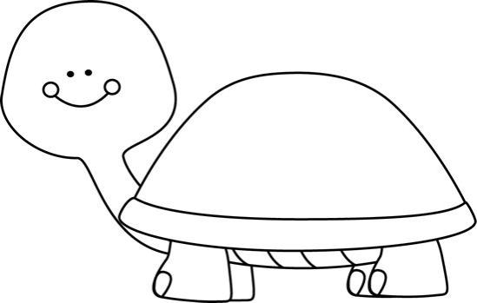

1. **10**
2. **3**

